// Bill Calculator

#include <stdio.h>

int main()

{

char product_name[20];

int quantity;

float price, bill_amount,discount=0,net_amount;

printf("product Name:");

scanf("%s",product_name);

printf("Quantity:");

scanf("%d",&quantity);

printf("Price:");

scanf("%f",&price);

bill_amount=quantity*price;

if(bill_amount>=5000)

discount=bill_amount*15/100; //bill_amount*0.15;

else

discount=bill_amount*10/100;

net_amount=bill_amount-discount;

printf("Bill amount:%f\n",bill_amount);

printf("Discount(-):;%f\n",discount);

printf(" ========================\n");

printf("%f\n",net_amount);

printf(" =========================\n");

return 0;

}

//OUTPUT

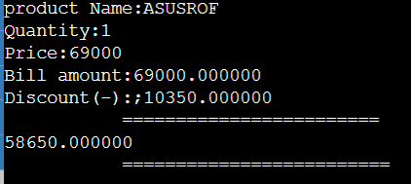

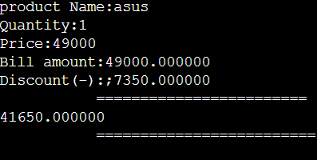

//program to check whether the number is divisible by 2&3

#include<stdio.h>

int main(){

int x;

scanf("%d",&x);

if(x%2==0){

if(x%3==0)

{

printf("%d is divisible by 2&3 ",x);

}

else

{printf("%d is divisible by 2 not 3",x);

}

}

else if(x%3==0){

printf("%d is divisible by 3 not 2",x);

}

else{

printf("%d is not divisible by 2&3",x);

}

return 0;

}

//OUTPUT



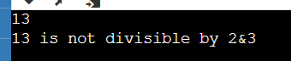

//program to check whether the number is divisible by 2&3

#include<stdio.h>

void main(){

float cgpa;

printf("enter the cgpa of the student");

scanf("%f",&cgpa);

if(cgpa>=10||cgpa<0)

printf("INVALID");

else if(cgpa>=9)

printf("grade is O");

else if(cgpa>=8&&cgpa<=8.99)

printf("grade is A");

else if(cgpa>=7&&cgpa<=7.99)

printf("grade is B");

else if(cgpa>=6&&cgpa<=6.99)

printf("grade is C");

else if(cgpa>=5&&cgpa<=5.99)

printf("grade is C");

else

printf("NO CONDITION");

}

//OUTPUT





